How does metacognition help me to learn better?
Skill development
Back to Learning Support
Understanding Cognition and Metacognition
Cognition refers to the mental processes involved in acquiring knowledge and understanding. This includes processes like thinking, understanding, learning, and remembering. It’s essentially what happens when a student reads, solves problems, or listens to a lecture.
Metacognition is thinking about how you think. It’s the ability to reflect on and control your cognitive processes. When students use metacognition, they monitor and evaluate how well they are learning, recognize whether they understand something, and adjust their strategies if needed.
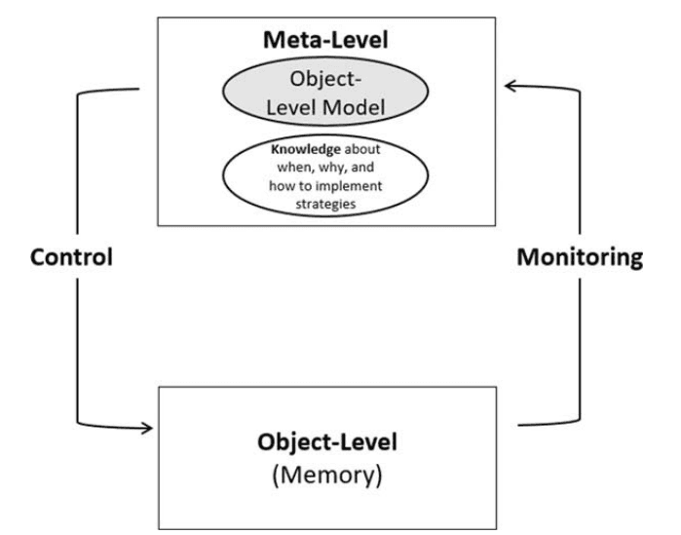Rivers, M. L. (2021). Metacognition about practice testing: A review of learners' beliefs, monitoring, and control of test-enhanced learning. Educational Psychology Review, 33, 1133–1167.
Example of cognition vs metacognition for learning
A student reading a history textbook is using cognition when they:
- Focus on the content.
- Try to remember important dates and facts.
- Summarize the material in their own words.
In this case, activities like comprehension, memorization, and summarization are basic cognitive tasks necessary to learn and understand the material.
Now imagine the same student stops after reading a section and asks themselves:
- "Do I understand this?"
- "Should I re-read this paragraph?"
- "How can I remember this information for the exam?"
As a result of this reflection, they may start using a different, more appropriate strategy, like making a mind map or testing themselves.
These actions involve metacognition because the student is reflecting on their learning process, assessing how well they’re learning, and adjusting strategies to learn more effectively.
Why is Metacognition Important?
Metacognition provides a framework for understanding and controlling one's thinking process, helping you take ownership of the learning process. Metacognition is the engine that powers your ability to upgrade your learning.
In the cycle of practice-reflection-learning, metacognition is what allows us to learn from mistakes, realise our habits and tendencies, and therefore make effective changes to practise next time.
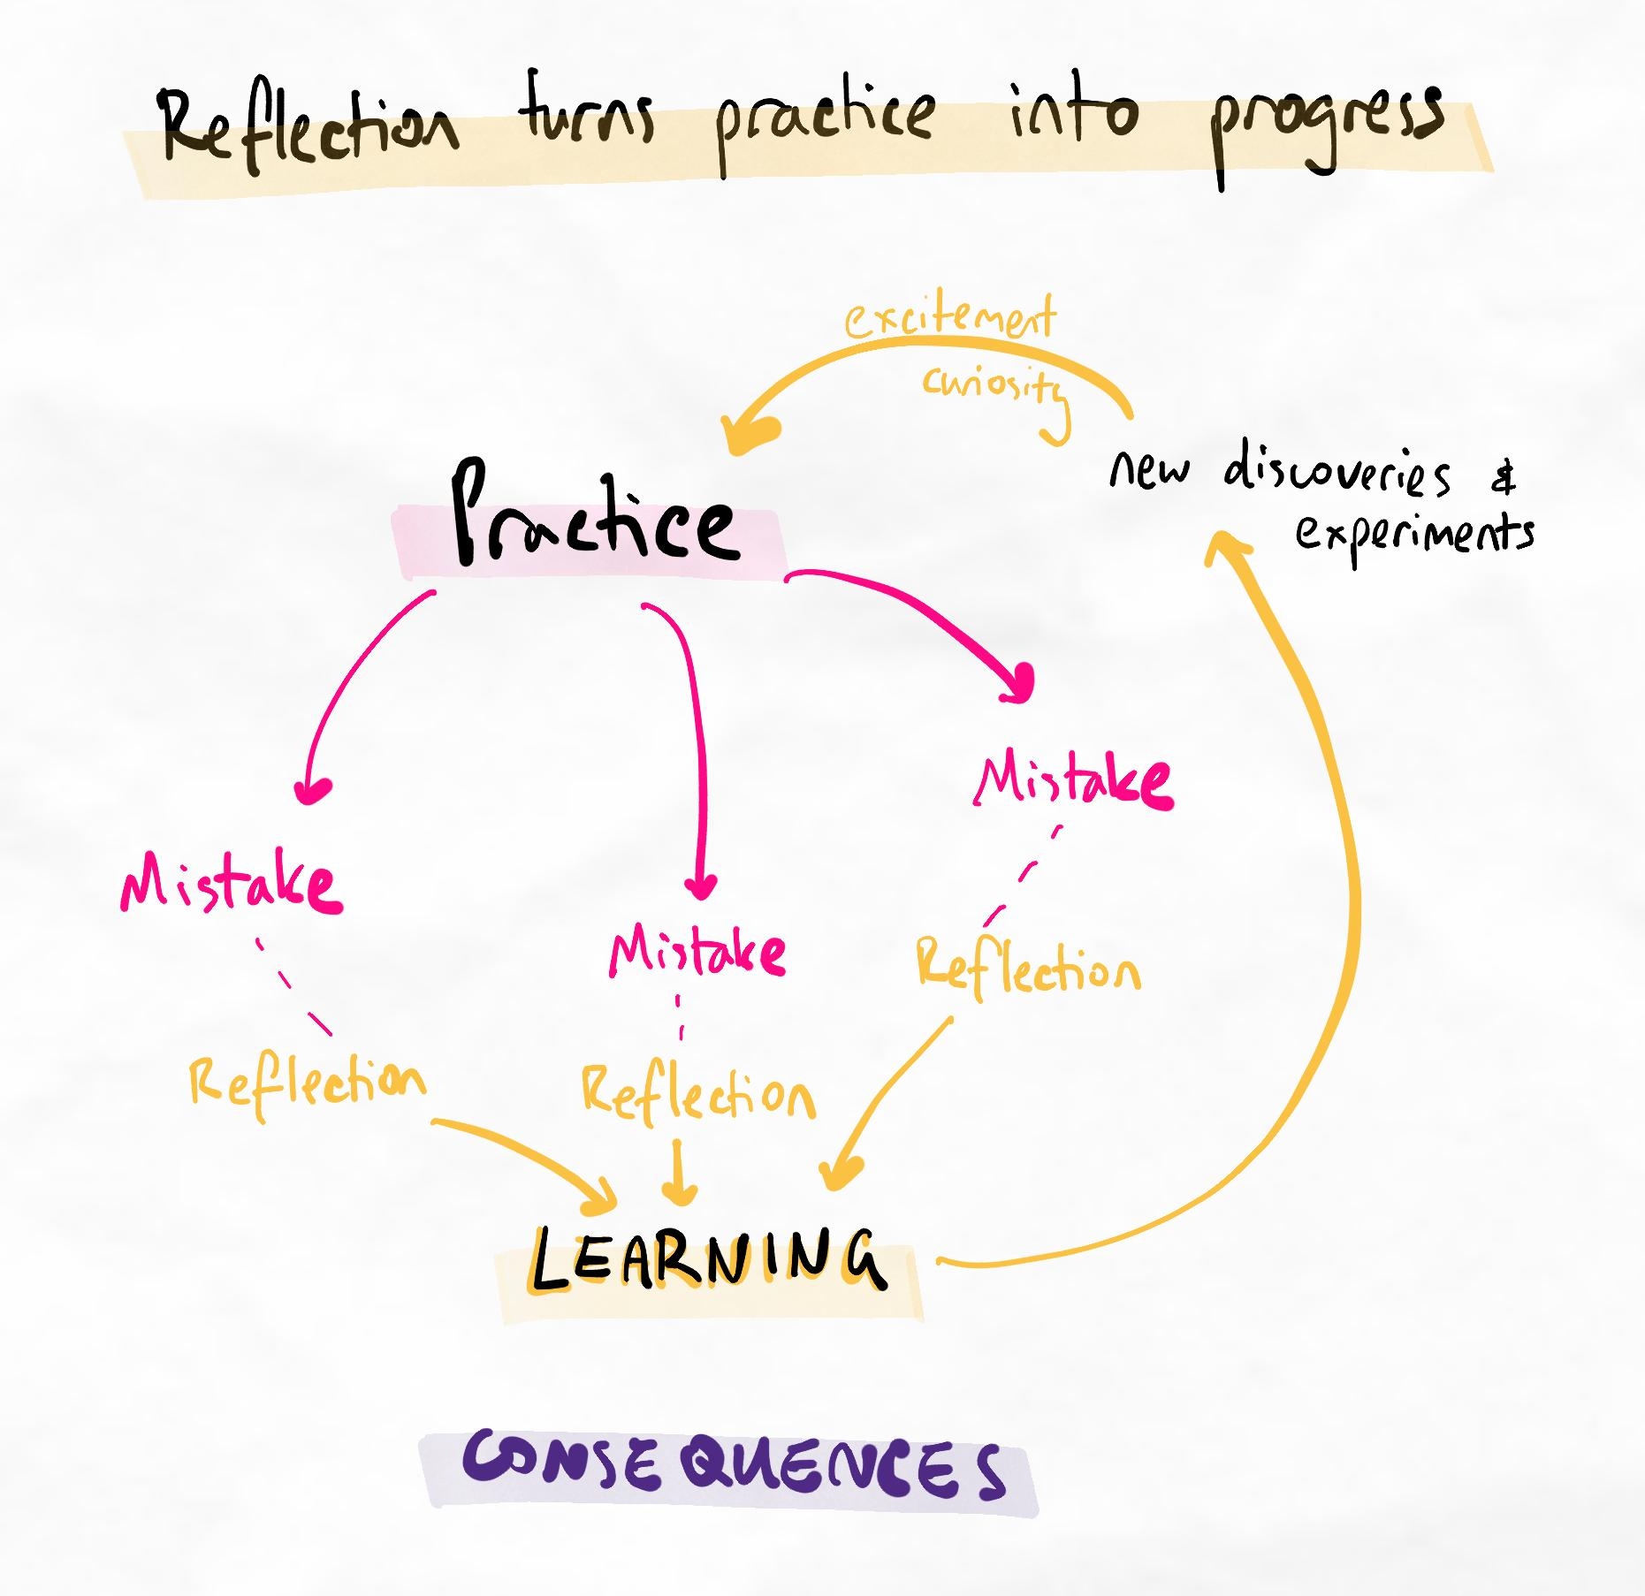
The infinite loop of practice-mistakes-reflection-learning
Metacognitive skills are also transferrable. This means that once you learn to plan, monitor, and evaluate in one area, you can apply these skills to other subjects and life areas, such as problem-solving or time management.
Benefits of high levels of metacognition
- Better self-regulation: Metacognition fosters self-reliance and proactive learning by helping you identify areas for improvement, choose effective methods, and adjust as needed.
- Adaptability: Metacognitive awareness helps learners think strategically about tasks, decide which strategies to use, and change tactics if needed.
- Better results: Awareness of your thinking allows you to choose effective study strategies, leading to better outcomes.
- Confidence and motivation: Reflecting on learning helps you understand your strengths and weaknesses, builds confidence, and boosts motivation.
Enhancing metacognition
The primary goal of metacognition is to improve awareness of cognitive processes and then regulate them to be more effective.
Therefore, to enhance metacognitive thinking, we must:
- Develop awareness of what we are currently doing and how we currently think
- Learn the right ways to think (so we know what is effective and what is not)
- Practise regulating our processes and making adjustments
- Reflect and experiment to improve this skill
Deep dive: Types of metacognitive knowledge
In research, multiple types of metacognition are often discussed. If you are interested, here is a brief summary:
- Learning Context: Understanding your strengths and weaknesses as a learner (Person Knowledge), knowing the requirements of a task (Task Knowledge), and knowing various strategies and when to use them (Strategy Knowledge).
- Nature of Knowledge: Knowing facts or concepts (Declarative Knowledge), knowing how to perform a task (Procedural Knowledge), and knowing when and why to use specific strategies (Conditional Knowledge).
Understanding these types of knowledge allows you to select the best approach for any learning task. For example, understanding when to use flashcards to memorize vocabulary (task and strategy knowledge) or a mind map to understand the causes of historical events (conditional knowledge) is an example of metacognitive awareness.
Note: In our experience, clearly understanding the different types of metacognition has limited practical benefits. We believe it is simpler to think of developing metacognition and improving your performance as simply:
- Knowing about what you currently do (habits and processes)
- Knowing what you should do (learning theory and new techniques)
- Adjusting what you're doing now to what you should be doing, one step at a time.
Turning metacognition into action
The act of taking your insights and metacognition and changing your habits and processes is called self-regulation. In the research, this is sometimes just called regulation or self-regulated learning.
In this article, we will use the term self-regulation.
Self-regulation involves monitoring and controlling your thinking to achieve learning goals. This includes:
- Planning: Set goals and decide which strategies to use before learning.
- Monitoring: Track your progress to see if you are applying the strategies correctly and thinking correctly with the right processes.
- Evaluating: Reflect on your learning processes and decide how to improve next time.
Frameworks taught in our program (i.e. Marginal Gains Tracking & Stacking and Kolb’s Experiential Cycle) closely align with metacognitive thinking and can, therefore, be useful for practising metacognition.
Metacognition never ends!
Metacognition is a continuous process that happens at all stages of learning. Before studying, it involves thinking about the strategies to use and how to approach your session. During studying, it involves monitoring how effective your strategies are and how well you are using them (and making changes if necessary). After studying, it involves reflecting on your experience to make productive changes for next time.
Enhancing Kolb's and reflections with metacognition
Kolb's (taught in Briefing) helps to improve your rate of improvement by deepening your metacognition. Here are some tips to make your Kolb's more effective:
Instructions...
- Focus on metacognition during the reflection. Reflect on what happened, but the value is in the questions prompting you to explore why it happened, what triggered it, how you reacted, and why you thought or acted the way you did.
- Identify trends in the abstraction. The abstraction isn't just to find patterns and common themes. You want to focus on habits or tendencies or beliefs (that you might not be aware of) that are producing the events you reflected on during the Reflection.
- Avoid circular feelings. Don't just state every feeling you had during the reflection or abstraction. Explore what triggered those feelings and how you responded to them. These are valuable for creating experiments.
- Take small steps. Remember to use marginal gains to track and stack your progress. Don't create experiments or reflect on massive experiences where identifying your 1% improvement is impossible!

